
USER INTERFACE DESIGN
23CSE113
LAB MANUAL
SUBMITTED BY
NAME | K.GAYATHRI
ROLL NO | AV.SC.U4CSE25120
YEAR/SEM/SECTION | 1ST YEAR/SEM-2/CSE-B
CREDITS | 03

SUBMITTED TO | DR. RAJ KUMAR BATCHU
DESIGNATION | ASST.PROFFESSOR(SL Grade)
DEPARTMENT | SCHOOL OF COMPUTING
INDEX
S.NO | TITLE | PAGE NO | REMARKS
1. | WEEK 1 : 1. Installation of VS CODE tool  2. Understanding basic of html  structure  3. Understanding basic html tags | 3-10
2. | WEEK 2 : 1. Designing a Web Page  Using HTML Tags
3. | WEEK 3 : 1. Construction of Class  Timetable using html Elements  2 . Construction of web page  Displaying Each Syllabus of each  Subject Displaying as Image  Format and also  isplaying the Corresponding time table of current semester
4. | Week 4: 1 . a college wants to collect student details through an online admission form design a registration form using only html tags(no css) with propern labels table alignment,background color and borders 2 . A Company wants to design a webpage that display two different forms side by side using iframes in which one should display a login form and other should display register form

LAB -1 1. VS CODE INSTALLER step – 1
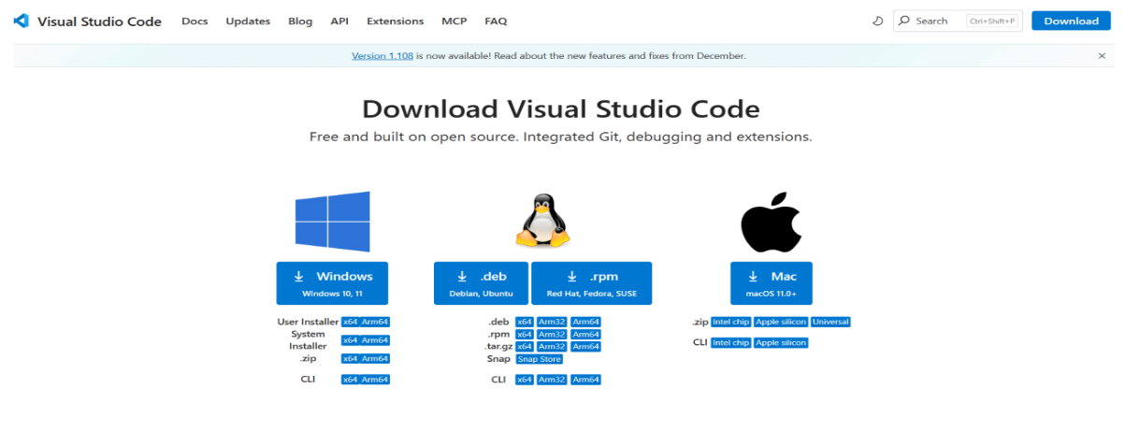
step – 2
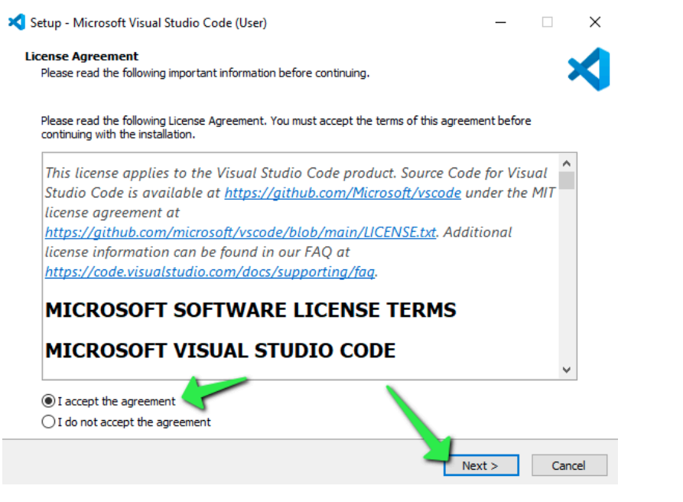

step -3
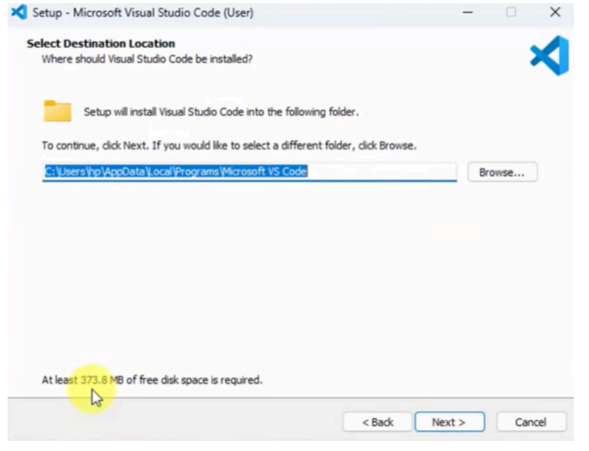
step – 4
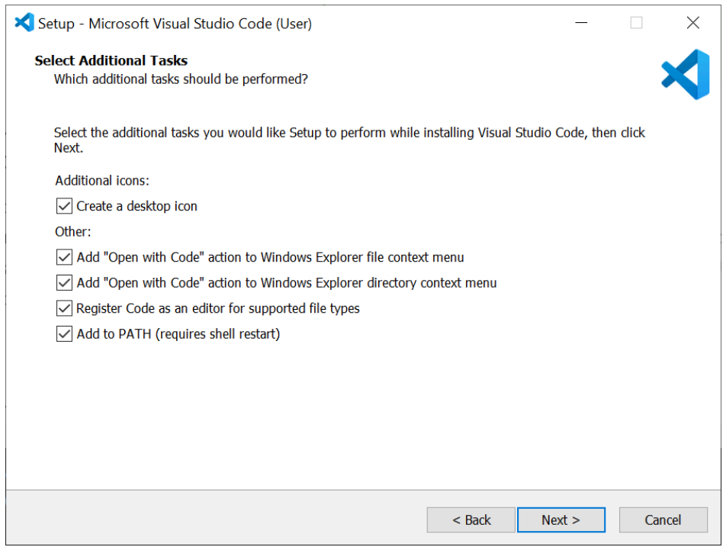
step – 5
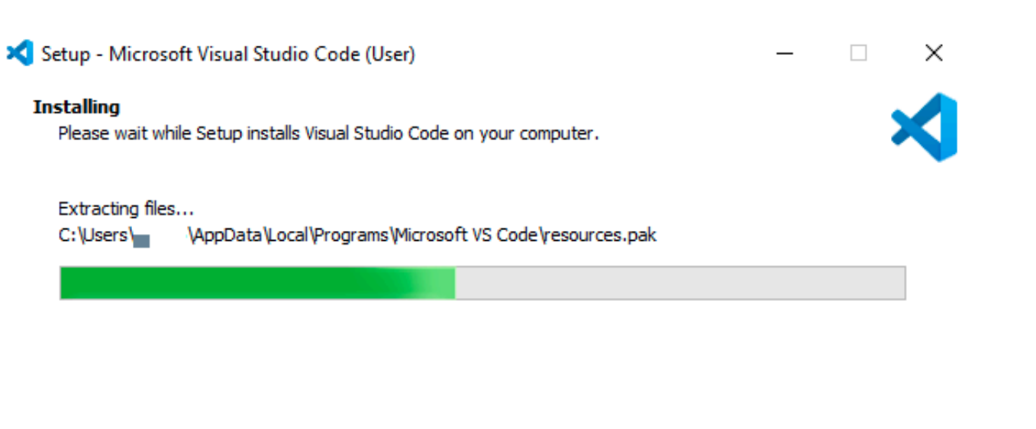
STEP-6
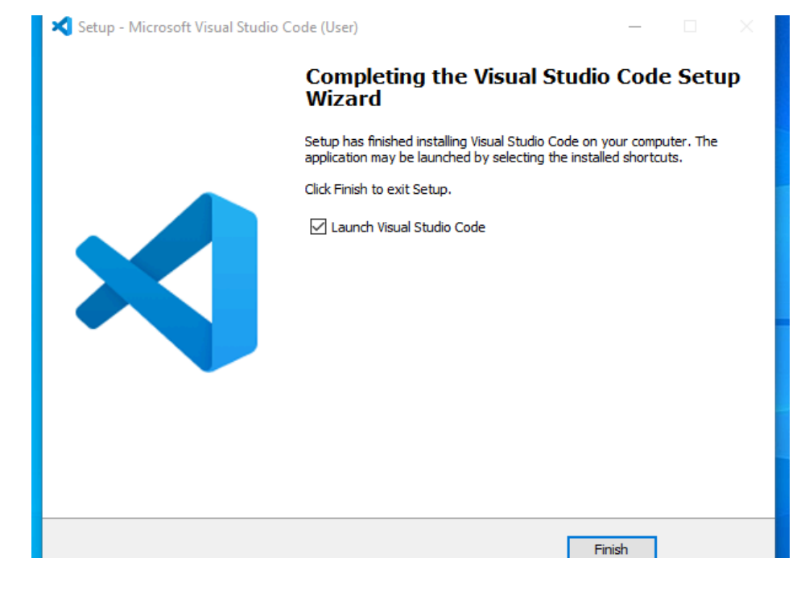
STEP 7:
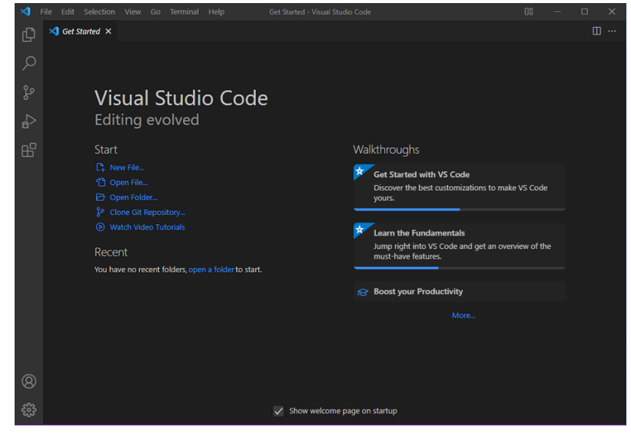

2.Understanding the structure of HTML a. Aim : To learn the basics of html( basics.html) Program:
<!DOCTYPE html>
<html>
<head>
<title>first web page</title>
</head>
<body>
<h1>happy to learn HTML</h1>
<p>this is my first sample code</p>
</body>
</html>

OUTPUT:
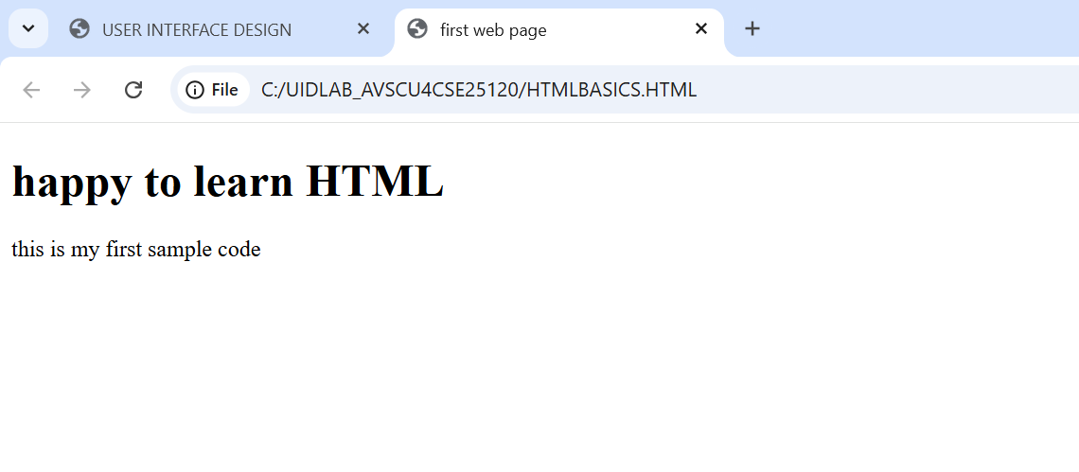

b. Aim: To learn headings in html( headings.html ) Program:
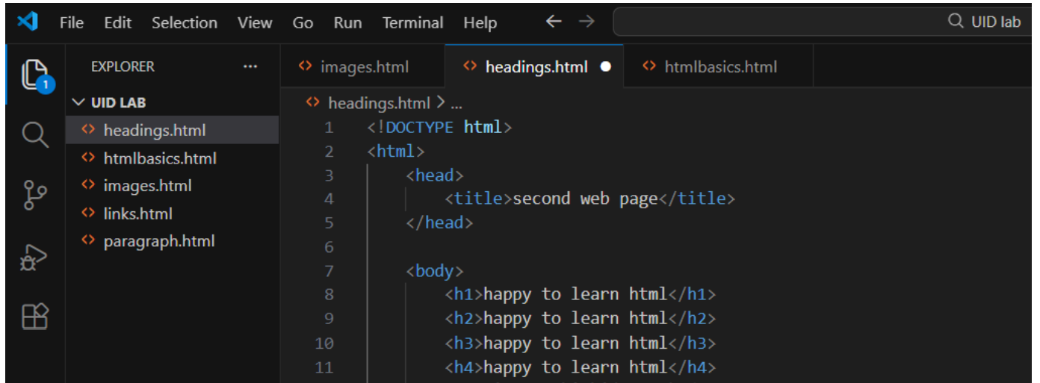
OUTPUT:
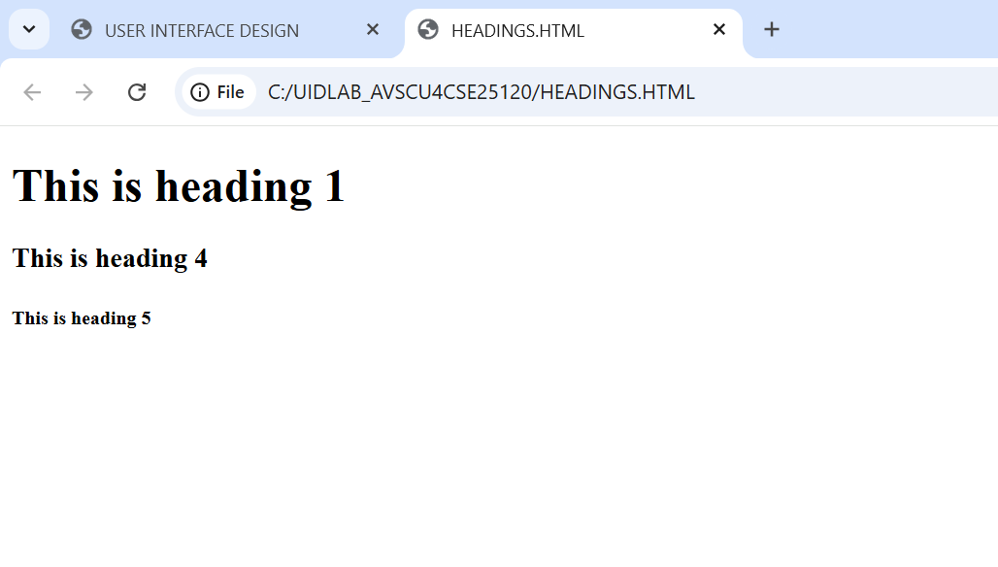

c. Aim: To learn writing a paragraph ( paragraph.html) Program:
<!DOCTYPE html>
<html>
<body>
<p>the given below details are my personals</p>
<p> i am gayathri studying my btech (25120)</p>
</body>

</html>

<!DOCTYPE html>
<html>
<body>

<p>the given below details are my personals</p>
<p>i am gayathri <br> studying my btech</p>
</body>
</html>

Output:
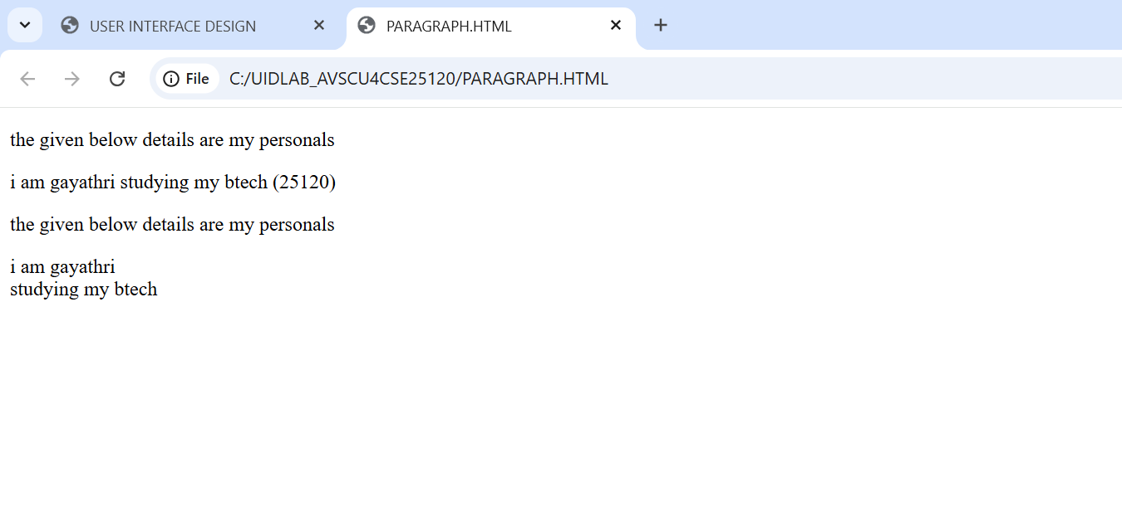
d. Aim: To learn opening links(links.html) Program:
<!DOCTYPE html>
<html>
<head>
<title>links</title>
</head>
<body>
<p> gayathri (25120)</p>
<p>this is the link to open w3schools</p>
<a href="https://www.W3schools.com">this is a link</a>
</p>
</body>
</html>

Output:
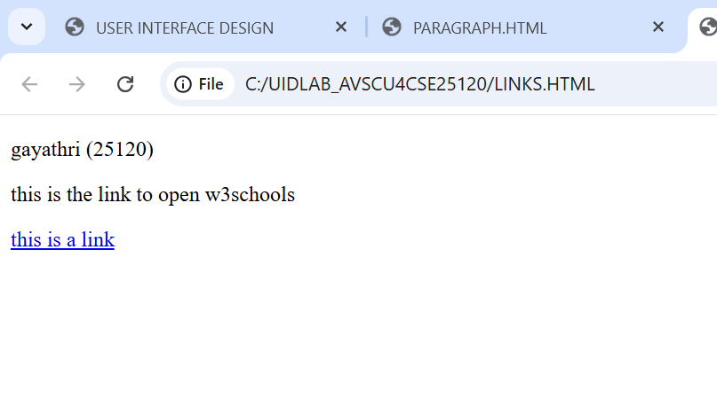
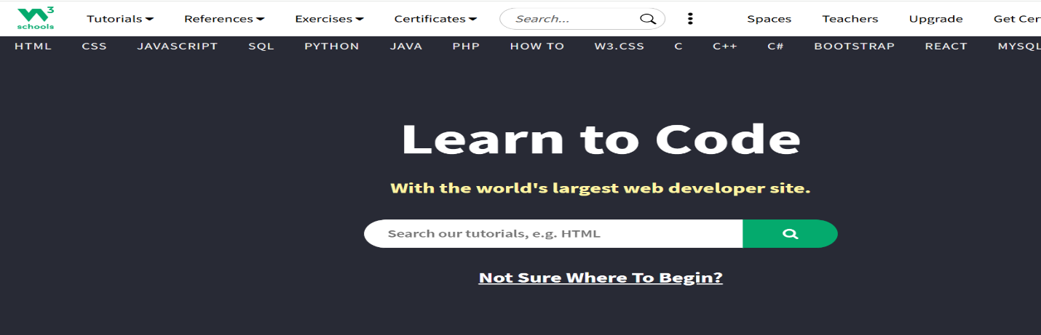
e. Aim: To learn to show images on web page (image.html ) Program:
<!DOCTYPE html>
<html>
<head>
<title>MS DHONI</title>
</head>
<body>
<h1> thala for a reason</h1>
<img src=https://media.gettyimages.com/id/1494318222/photo/final-chennai-super-kings-v-gujarat-titans.jpg?s=612x612&w=gi&k=20&c=yuUFkCBW8-NJQv4bFmt9nl_0lh05vvXHYkC27DGjDfc=>
</body>
</html>

Output: 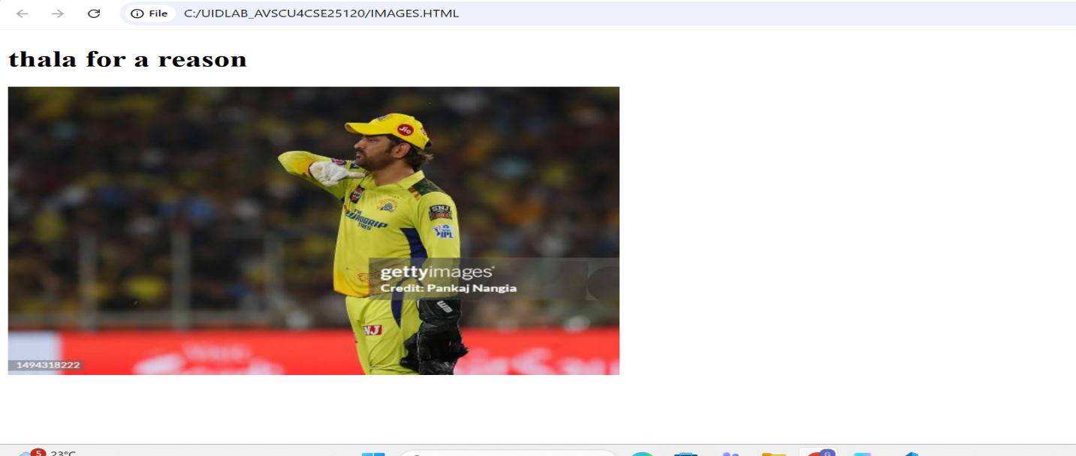

Explanation of the tags:
HTML stands for Hyper Text Markup Language.
HTML is used to create and structure web pages.
It tells the web browser what to display and how to display it.
<DOCTYPE HTML> : The element tells the browser , this is an HTML5 document
<html> : The element is the root element of an HTML page.
<head> : The element contains meta information about the HTML page.
<p>:the <p> element defines a paragraph.

Week-2
- Aim : To create a static webpage using HTML that displays basic information about Amrita Vishwa Vidyapeetham , including a heading,descriptive text , background styling through HTML attributes and a table showing the list of campusesin different states
Procedure:
- <!DOCTYPE html>
- <html>
- <head>
- <title>Amrita vishwa vidhyapeetam</title>
- </head>
- <body style="background-color:rgb(255, 244, 230);
- background-image:url(https://webfiles.amrita.edu/2022/03/nbElb5oz-amrita-amaravati-campus-banner-2022.jpg);
- background-size: cover ; background-repeat: no repeat;">
- <h1 style="text-align:center; color:rgb(0, 0, 0);border: 3px solid black;
- font-family: 'Times New Roman', Times, serif;"> Amrita vishwa vidhyapeetam</h1>
- <h2 style="text-align: center; color: black;font-family: 'Times New Roman', Times, serif;">
- Amaravathi Campus </h2><pre style="text-align: center;font-family: 'Times New Roman', Times, serif;color:rgb(226, 239, 237);
- font-size: large;">
- The Amrita Amaravati campus is a 200-acre, research-driven institution in Andhra Pradesh's greenfield capital.
- Accredited with a NAAC 'A++' grade and ranked among India's top 10 universities by NIRF 2025,
- it offers industry-aligned programs in Engineering, Management, and Sciences.
- Known for its "Education for Life" philosophy, the campus blends
- high-tech infrastructure with ethical values
- </pre>
- <table border="2"; align="center"; cellpadding="5";cellspacing="10"; width="60%";
- style="background-color:floralwhite;">
- <tr>
- <th>s.no</th>
- <th>campus</th>
<th>location</th>
- <th>number</th>
- <th>Link</th>
- </tr>
- <tr>
- <td>1.</td>
- <td >Amaravathi</td>
- <td >kuragallu</td>
- <td>+91-8645277800</td>
- <td >https://www.amrita.edu/campus/amaravati/</td>
- </tr>
- <tr>
- <td>2.</td>
- <td >coiambatore</td>
- <td >ettimadai</td>
- <td>+91-8645271800</td>
- <td >https://www.amrita.edu/campus/coiambatore/</td>
- </tr>
- <tr>
- <td>3.</td>
- <td >banglore</td>
- <td >junnasandra</td>
- <td>+91-8645272800</td>
- <td >https://www.amrita.edu/campus/banglore/</td>
- </tr>
- <tr>
- <td>4.</td>
- <td >amritapuri</td>
- <td >vallikavu</td>
- <td>+91-8645273800</td>
- <td >https://www.amrita.edu/campus//</td>
- </tr>
- </table>
- </body>
- </html>

OUTPUT:

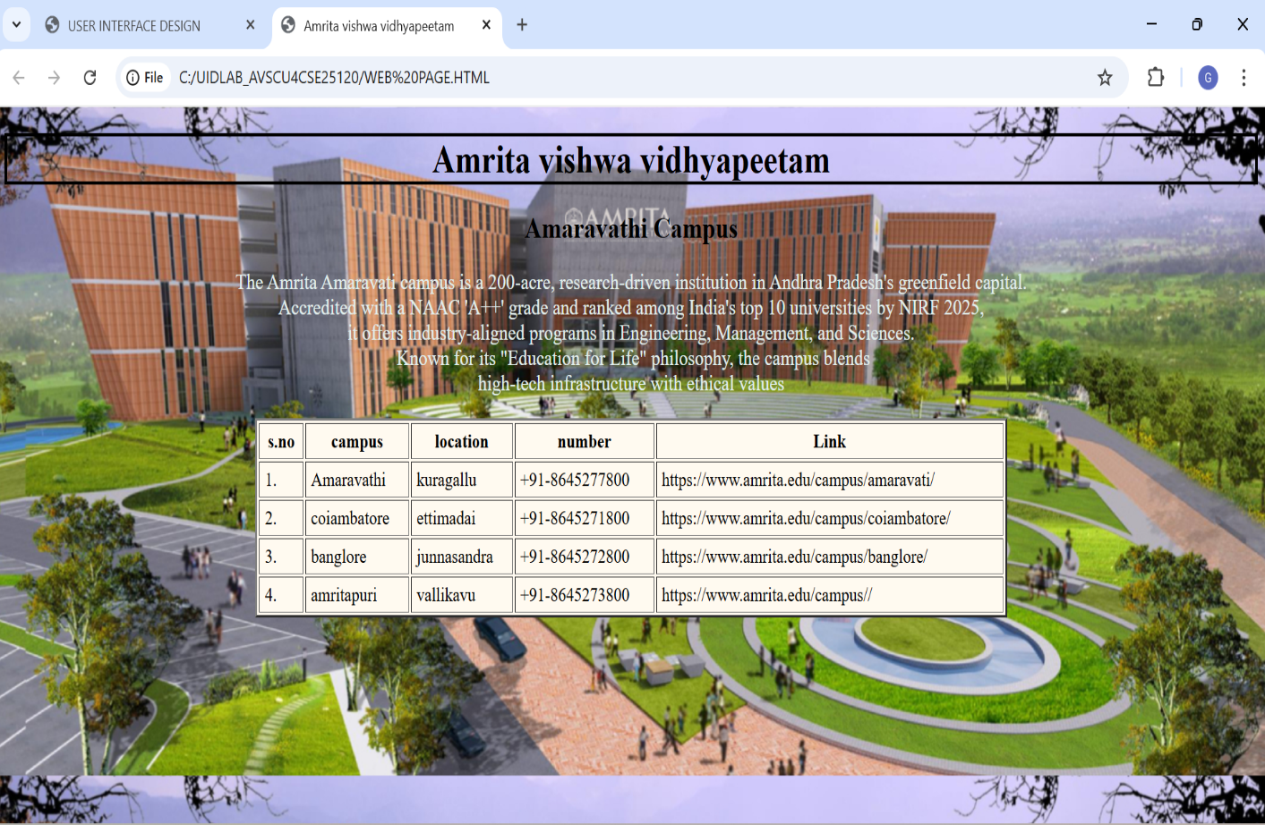

Explanation of the tags:

<h1>,<h2>– Heading tags for main title and subtitle.

<pre> – Displays text in preformatted style, preserving space and line breaks.

<table>– Createtable to arrange data in rows and columns.

Attributes: border, align, cellpadding, cellspacing, width.

<tr>– Defines a table row.
<th>– Table heading cell (bold and centered).

<td>– Table data cell for normal content.
Inline CSS (style attribute) – Used to set background color, image, font, alignment, and borders.

2.Aim : To design a webpage using HTML that demonstrated the use of background colour background image,heading styling and performatted text.

Procedure:

<!DOCTYPE html>
<html>
<head>
<title>Simple Web Page Demo</title>
<style>
/* Background color and image */
body {
background-color: antiquewhite; /* Background color */
background-image: url("https://wallpapers.com/images/hd/aesthetic-computer-pictures-yd6kon54y013rjzh.jpg");
background-repeat: no-repeat;
background-size: cover;
background-attachment: fixed;
font-family: Arial, sans-serif }
/* Heading styling */
h1 {
color: blueviolet;
text-align: center;
text-decoration: underline;
font-size: 40px; }
h2 { color: darkred;
margin-left: 20px;}
/* Paragraph styling */
p { font-size: 18px;
margin-left: 20px; }
/* Preformatted text styling */
pre {
background-color: white;
padding: 15px;
border: 2px solid black;
width: fit-content;
margin-left: 20px;}
</style>
</head>
<body>
<h1>Welcome to My Web Page</h1>
<h2>About This Page</h2>
<p>This page demonstrates background color, background image, heading styling, and preformatted text in HTML.</p>
<h2>Sample Preformatted Text</h2>
<pre>
Name : gayathri
Course : user interface design
College : Amrita University
</pre></body></html>

Output :
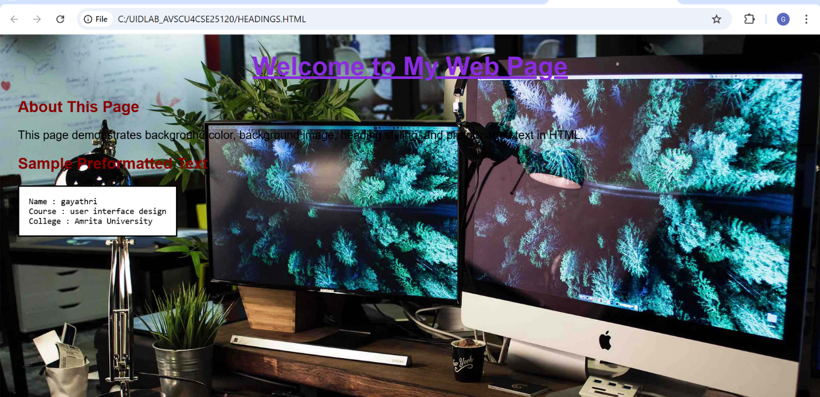

Explanation of the tags: h1>,
→ Headings
→ Paragraph
→ Preformatted text
2cAim: To design a restaurants menu webpage using HTML and displaying menu items in a table format with proper layout and visual styling.

Procedure :
<!DOCTYPE html>
<html>
<head>
<title>paradise restaurant - Luxury Edition</title>
<link href="https://fonts.googleapis.com/css2?family=Playfair+Display:ital@1&display=swap" rel="stylesheet">
<style>
body { margin: 0;
font-family: 'Playfair Display', serif;
background: url(https://imgmediagumlet.lbb.in/media/2025/03/67c59f4d2226626b47ecaf25_1741004621323.jpg) no-repeat center center fixed;
background-size: cover;
color: rgb(0, 255, 30);}
.header { background: rgba(0, 0, 0, 0.85);
text-align: center;
padding: 35px;
font-size: 40px;
letter-spacing: 3px;
font-style: italic;
color: rgb(21, 0, 255);
border-bottom: 3px solid; }
.menu-section { width: 85%;
margin: 40px auto;
padding: 25px;
border-radius: 15px;
background: rgba(0, 0, 0, 0.75);
box-shadow: 0 8px 25px rgba(0,0,0,0.8);
h2 { text-align: center;
font-style: italic;
font-size: 28px;
color: rgb(255, 0, 230);
border-bottom: 2px solid rgb(0, 0, 255);
padding-bottom: 10px; }
table {width: 100%;
border-collapse: collapse;
margin-top: 20px;
font-style: italic;}
th, td { padding: 14px;
text-align: center; }
th { color: rgb(255, 0, 221);
font-size: 20px;
border-bottom: 2px solid rgb(255, 140, 0); }
tr {background: transparent; }
tr:hover { background: rgba(0, 179, 255, 0.15);
transition: 0.3s; }
.price { color: #ff0000;
font-weight: bold; }
.footer { text-align: center;
padding: 20px;
background: rgba(0, 0, 0, 0.9);
color: rgb(0, 255, 149);
font-style: italic;
border-top: 2px solid rgb(255, 0, 30); }
</style>
</head>
<body>
<div class="header">
AHAARUCHI
⭐⭐⭐⭐⭐
</div><div class="menu-section">
<h2>Signature Starters</h2>
<table>
<tr>
<th>Item</th>
<th>Description</th>
<th>Price</th>
</tr>
<tr>
<td>Truffle Paneer Bites</td>
<td>Luxury grilled paneer infused with truffle essence</td>
<td class="price">₹320</td>
</tr> <tr>
<td>Royal Chicken Platter</td>
<td>Premium spiced chicken with exotic herbs</td>
<td class="price">₹450</td>
</tr> <tr>
<td>Golden Prawn Tempura</td>
<td>Crispy fried prawns served with signature sauce</td>
<td class="price">₹520</td>
</tr><tr>
<td>Herb Stuffed Mushrooms</td>
<td>Baked mushrooms filled with creamy herbs</td>
<td class="price">₹300</td>
</tr> <tr>
<td>Cheese Stuffed Jalapeños</td>
<td>Spicy jalapeños filled with rich cheese</td>
<td class="price">₹280</td>
</tr>
</table>
</div>
<div class="menu-section">
<h2>Chef’s Special Entrées</h2>
<table> <tr>
<th>Item</th>
<th>Description</th>
<th>Price</th> </tr>
<tr> <td>Imperial Mutton Biryani</td>
<td>Slow-cooked aromatic rice with premium mutton</td>
<td class="price">₹550</td> </tr>
<tr> <td>Golden Cream Pasta</td>
<td>Rich Alfredo sauce with fine herbs</td>
<td class="price">₹380</td> </tr>
<tr> <td>Grilled Salmon Steak</td>
<td>Fresh salmon grilled to perfection</td>
<td class="price">₹650</td> </tr>
<tr> <td>Royal Butter Chicken</td>
<td>Creamy tomato gravy with tender chicken</td>
<td class="price">₹480</td> </tr>
<tr> <td>Luxury Veg Lasagna</td>
<td>Layered pasta with cheese and vegetables</td>
<td class="price">₹420</td> </tr>
</table></div>
div class="menu-section">
<h2>Luxury Desserts</h2>
<table>
<tr> <th>Item</th>
<th>Description</th>
<th>Price</th>
</tr><tr>
<td>Belgian Chocolate Delight</td>
<td>Premium dark chocolate layered dessert</td>
<td class="price">₹290</td>
</tr> <tr>
<td>Royal Saffron Kulfi</td>
<td>Traditional saffron-infused frozen dessert</td>
<td class="price">₹220</td>
</tr> <tr>
<td>Strawberry Cheesecake</td>
<td>Creamy cheesecake topped with strawberries</td>
<td class="price">₹310</td>
</tr> <tr>
<td>Tiramisu Classic</td>
<td>Italian layered coffee-flavored dessert</td>
<td class="price">₹350</td>
</tr></table>
</div>
div class="menu-section">
<h2>Premium Beverages</h2>
<table> <tr> <th>Item</th>
<th>Description</th>
<th>Price</th></tr>
<tr> <td>Fresh Fruit Mocktail</td>
<td>Blend of seasonal fruits with sparkling soda</td>
<td class="price">₹190</td> </tr>
<tr> <td>Classic Cappuccino</td>
<td>Rich espresso topped with frothy milk</td>
<td class="price">₹160</td>
</tr> <tr>
<td>Blue Lagoon</td>
<td>Refreshing citrus drink with blue curacao flavor</td>
<td class="price">₹210</td>
</tr> <tr><td>Mint Mojito</td>
<td>Fresh mint with lime and soda</td>
<td class="price">₹170</td></tr>
</table>
</div><div class="footer">
Experience Luxury Dining | Contact: 9727727180
</div>
</body>
</html>
Output:
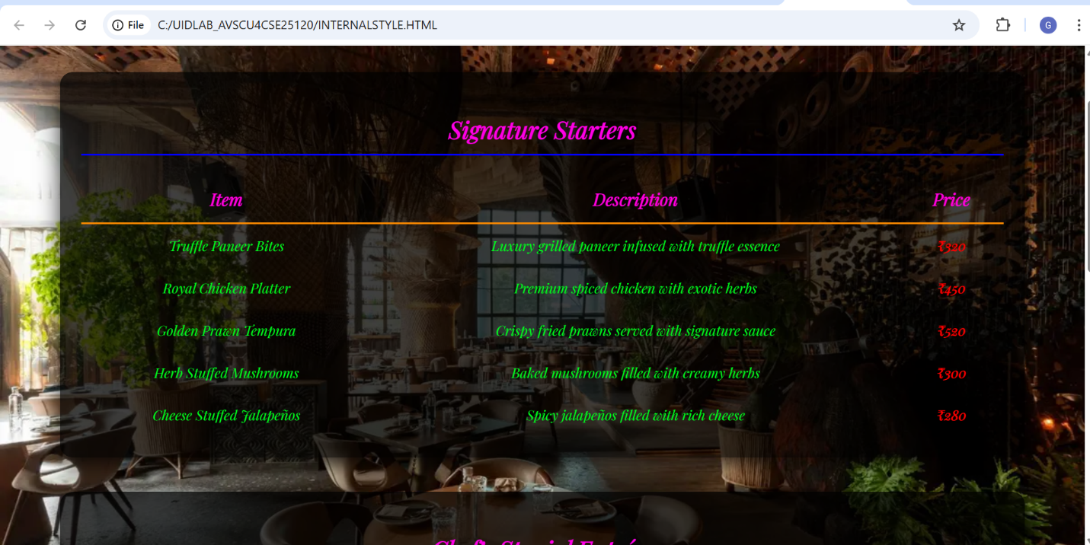

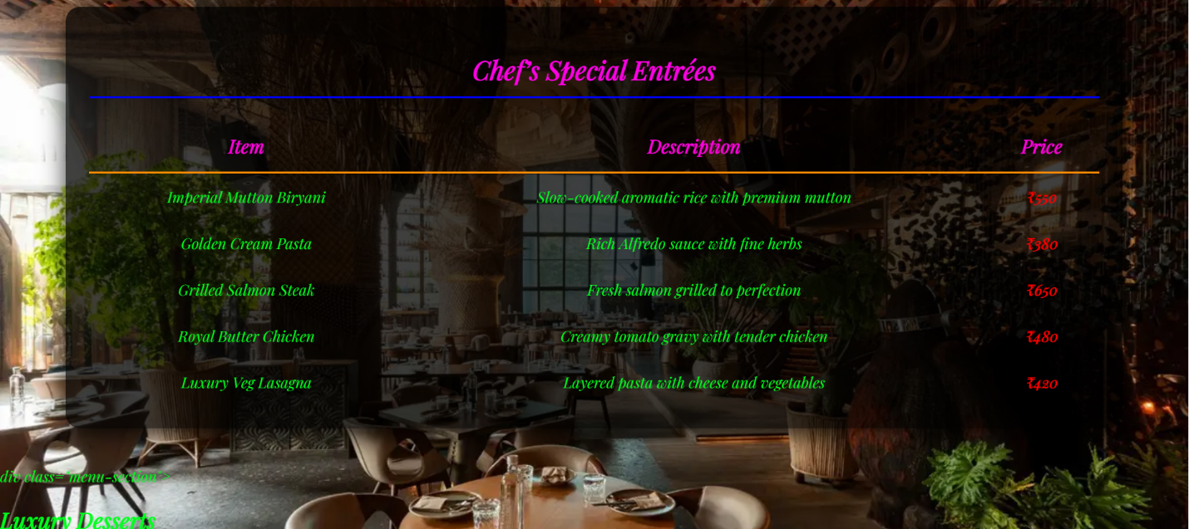

Week-3
- Aim: Construction of Class Timetable using html Elements
Program:
<!DOCTYPE html>
<html>
<head>

<title>CSE-B Semester II Timetable</title>
<style>
table { width: 100%; border-collapse: collapse; font-family: Arial, sans-serif; }
th, td { border: 1px solid #444; padding: 8px; text-align: center; font-size: 12px; }
th { background-color: #f2f2f2; }
.break { background-color: #e8e8e8; font-style: italic; }
.header-info { margin-bottom: 20px; }
</style>
</head>
<body>

<div class="header-info">
<h2>Dept. CSE - Class: B. Tech. CSE-B (Sem-II)</h2>
<p><strong>Venue:</strong> Room 511</p>
<p><strong>Class Advisors:</strong> Dr. K.G.R. Narayan & Dr. Ankit Sachan</p>
</div>

<table>
<thead>
<tr>
<th>Time / Day</th>
<th>08.55-10.35 (Slot 1 & 2)</th>
<th>10.35-10.45</th>
<th>10.45-11.35 (Slot 3)</th>
<th>11.35-12.25 (Slot 4)</th>
<th>12.25-01.15 (Slot 5)</th>
<th>01.15-02.05</th>
<th>02.10-03.00 (Slot 6)</th>
<th>03.10-04.50 (Slot 7 & 8)</th>
</tr>
</thead>
<tbody>
<tr>
<td><strong>Monday</strong></td>
<td>23MAT117 Linear Algebra LAB</td>
<td class="break">Short Break</td>
<td>LIBRARY</td>
<td>23PHY115 Modern Physics</td>
<td>LIBRARY</td>
<td class="break">Lunch</td>
<td colspan="2">23MEE115 Manufacturing Practice LAB</td>
</tr>
<tr>
<td><strong>Tuesday</strong></td>
<td>23MAT116 Discrete Math / 23MAT117 Linear Algebra</td>
<td class="break">Short Break</td>
<td>23PHY115 Modern Physics</td>
<td>23CSE111 Object Oriented Programming</td>
<td>23CSE113 User Interface Design</td>
<td class="break">Lunch</td>
<td>Library/Sports</td>
<td>22ADM111 Glimpses of Glorious India</td>
</tr>
<tr>
<td><strong>Wednesday</strong></td>
<td>Prog Lab 2 / 23CSE111 Object Oriented</td>
<td class="break">Short Break</td>
<td>23MAT116 Discrete Mathematics</td>
<td>23CSE113 User Interface Design</td>
<td>22ADM111 Glimpses of Glorious India</td>
<td class="break">Lunch</td>
<td>COUNSELLING</td>
<td>Library/Sports</td>
</tr>
<tr>
<td><strong>Thursday</strong></td>
<td>23CSE111 OOP / 23MAT117 Linear Algebra</td>
<td class="break">Short Break</td>
<td>23MAT116 Discrete Mathematics</td>
<td>COUNSELLING</td>
<td>LIBRARY</td>
<td class="break">Lunch</td>
<td>23PHY115 Modern Physics (T)</td>
<td>Library/Sports</td>
</tr>
<tr>
<td><strong>Friday</strong></td>
<td>23CSE113 UI Design Lab (BYOD)</td>
<td class="break">Short Break</td>
<td>23MAT117 Linear Algebra</td>
<td>23CSE111 Object Oriented Programming</td>
<td>Library/Sports</td>
<td class="break">Lunch</td>
<td>22ADM111 Glimpses of India (P)</td>
<td>23MAT116 Discrete Math Lab</td>
</tr>
</tbody>
</table>

</body>
</html>

Output:
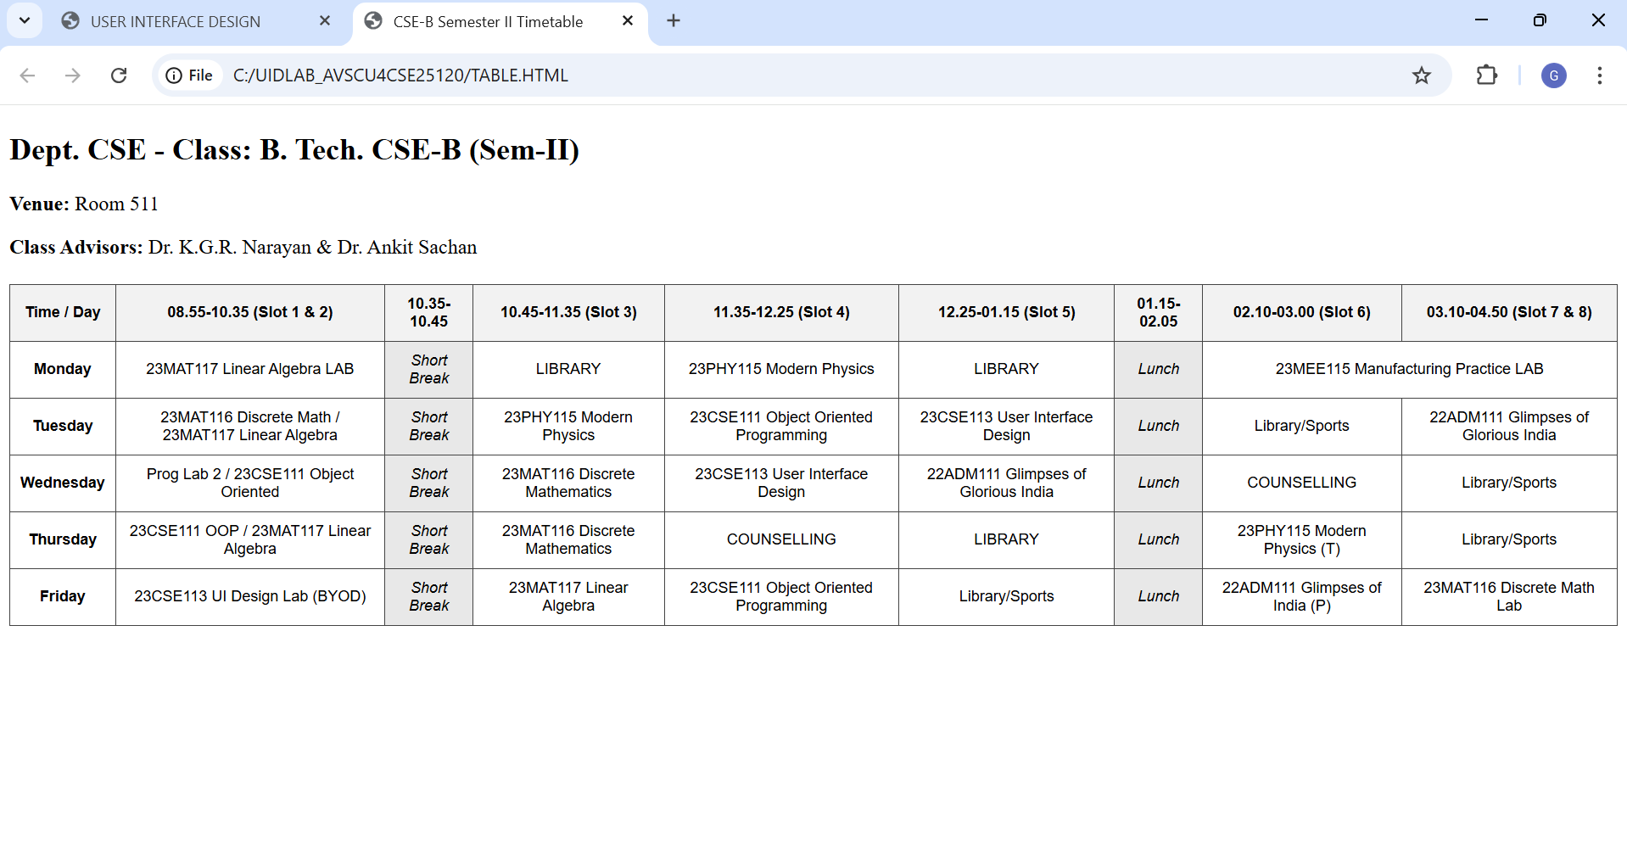

Explanation of the tags
<table>: is used to create the timetable structure with borders and spacing.
<tr>:defines table rows for each day.
<th>:is used for headings like time slots and days.
<td>:is used for headings like time slots and days. : is used to enter subjects and activities.
colspan :merges columns for lab hours.
rowspan : merges rows for short break and lunch break.
bgcolor :gives background color to break cells. class="vertical" : applies vertical text style.
style attribute changes text color for specific cells.

2 . Aim: Construction of web page Displaying Each Syllabus of each Subject Displaying as Image Format and also displaying the Corresponding time table of current semester
Program:
UIDLAB-CSE25120
<!DOCTYPE html>
<html>
<head>
<title>Syllabus, Faculty & Master Time Table</title>
<style>
body{
font-family: Arial;
background-color: #f2f6ff;
text-align: center;
}
h2{
margin: 25px 0 15px 0;
}
/* Gallery */
.gallery{
display: grid;
grid-template-columns: 1fr 1fr ;
gap: 25px;
width: 90%;
margin: auto;
}
.card{
background-color: white;
padding: 10px;
border-radius: 10px;
border: 2px solid black;
}
.card img{
width: 100%;
border-radius: 8px;
}
.title{
font-weight: bold;
font-size: 18px;
margin: 8px 0;
}
.faculty{
color: #333;
margin-bottom: 8px;
}
/* Tables */
table{
border-collapse: collapse;
margin: 30px auto;
background-color: white;
width: 95%;
}
th{
background-color: #dbe4f2;
}
td, th{
border: 1px solid black;
padding: 8px;
text-align: center;
}
.break{
background-color: yellow;
font-weight: bold;
}
.vertical {
writing-mode: vertical-rl;
transform: rotate(180deg);
text-align: center;
font-weight: bold;
letter-spacing: 2px;
}
</style>
</head>
<body>
<h2>SUBJECT SYLLABUS & FACULTY</h2>
<div class="gallery">
<div class="card">
<div class="title">23MAT116 – Discrete Mathematics</div>
<div class="faculty">Faculty: Dr. Srivasa Rao Thota</div>
<img src="C:\Users\Divya\OneDrive\Desktop\UID lab\syllabusproject\img1.png.png">
</div>
<div class="card">
<div class="title">23MAT117 – Linear Algebra</div>
<div class="faculty">Faculty: Mr. Sapavat Bixapathi</div>
<img src="C:\Users\Divya\OneDrive\Desktop\UID lab\syllabusproject\img2.png.png">
</div>
<div class="card">
<div class="title">23CSE111 – Object Oriented Programming</div>
<div class="faculty">Faculty: Dr. Balaji TK</div>
<img src="C:\Users\Divya\OneDrive\Desktop\UID lab\syllabusproject\img3.png.png">
</div>
<div class="card">
<div class="title">23PHY115 – Modern Physics</div>
<div class="faculty">Faculty: Dr. C R Kesavalu</div>
<img src="C:\Users\Divya\OneDrive\Desktop\UID lab\syllabusproject\img4.png.png">
</div>
<div class="card">
<div class="title">23CSE113 – User Interface Design</div>
<div class="faculty">Faculty: Dr. Rajkumar Batchu<br>Assisting: Mr. Barge Bharadwaj</div>
<img src="C:\Users\Divya\OneDrive\Desktop\UID lab\syllabusproject\img5.png.png">
</div>
<div class="card">
<div class="title">23MEE115 – Manufacturing Practice Lab</div>
<div class="faculty">Faculty: Dr. Sathies S.</div>
<img src="C:\Users\Divya\OneDrive\Desktop\UID lab\syllabusproject\img6.png.png">
</div>
</div>
<h2 align="center">Master Time Table CSE II Semester B Section</h2>
<table border="1" cellspacing="0" cellpadding="8" align="center">
<tr>
<th>Time / Day</th>
<th>Slot 1<br>08:55–09:45</th>
<th>Slot 2<br>09:45–10:35</th>
<th>10:35–10:45</th>
<th>Slot 3<br>10:45–11:35</th>
<th>Slot 4<br>11:35–12:25</th>
<th>Slot 5<br>12:25–01:15</th>
<th>01:15–02:05</th>
<th>Slot 6<br>02:10–03:00</th>
<th>03:00–03:10</th>
<th>Slot 7<br>03:10–04:00</th>
<th>Slot 8<br>04:00–04:50</th>
</tr>
<tr>
<th>Monday</th>
<td colspan="2">23MAT117 Linear Algebra LAB (BYOD)</td>
<td rowspan="5" bgcolor="lightgreen" class="vertical">SHORT BREAK</td>
<td>LIBRARY</td>
<td>23PHY115 Modern Physics</td>
<td>LIBRARY</td>
<td rowspan="5" bgcolor="lightgreen" class="vertical">LUNCH BREAK</td>
<td>23MEE115 Manufacturing Practice LAB</td>
<td rowspan="5" bgcolor="lightgreen" class="vertical">SHORT BREAK</td>
<td colspan="2">23MEE115 Manufacturing Practice LAB</td>
</tr>
<tr>
<th>Tuesday</th>
<td>23MAT116 Discrete Mathematics</td>
<td>23MAT117 Linear Algebra</td>
<td>23PHY115 Modern Physics</td>
<td>23CSE111 Object Oriented Programming</td>
<td>23CSE113 User Interface Design</td>
<td>Library/Sports</td>
<td colspan="2">22ADM111 Glimpses of Glorious India</td>
</tr>
<tr>
<th>Wednesday</th>
<td colspan="2">23CSE111 OOPS Lab</td>
<td>23MAT116 Discrete Mathematics</td>
<td>23CSE113 User Interface Design</td>
<td>22ADM111 Glimpses of Glorious India</td>
<td style="color:sandybrown;">COUNSELLING</td>
<td colspan="2">Library/Sports</td>
</tr>
<tr>
<th>Thursday</th>
<td>23MAT117 Linear Algebra</td>
<td>23CSE111 Object Oriented Programming</td>
<td>23MAT116 Discrete Mathematics</td>
<td style="color:sandybrown;">COUNSELLING</td>
<td>LIBRARY</td>
<td>23PHY115 Modern Physics (T)</td>
<td colspan="2">Library/Sports</td>
</tr>
<tr>
<th>Friday</th>
<td colspan="2">23CSE113 User Interface Design Lab BYOD</td>
<td>23MAT117 Linear Algebra</td>
<td>23CSE111 Object Oriented Programming</td>
<td>Library/Sports</td>
<td>22ADM111 Glimpses of Glorious India (P)</td>
<td colspan="2">23MAT116 Discrete Mathematics Lab</td>
<tr>
<th colspan="1">Course Code</th>
<th colspan="3">Course Name</th>
<th>L-T-P</th>
<th>Credits</th>
<th colspan="3">Faculty Name</th>
<th colspan="3">Assisting Faculty</th>
</tr>
<tr>
<td colspan="1">23MAT116</td>
<td colspan="3">Discrete Mathematics</td>
<td>3-0-2</td>
<td>4</td>
<td colspan="3">Dr. Srivasa Rao Thota</td>
<td colspan="3"></td>
</tr>
<tr>
<td colspan="1">23MAT117</td>
<td colspan="3">Linear Algebra</td>
<td>3-0-2</td>
<td>4</td>
<td colspan="3">Mr. Sapavat Bixapathi</td>
<td colspan="3"></td>
</tr>
<tr>
<td colspan="1">23CSE111</td>
<td colspan="3">Object Oriented Programming</td>
<td>3-0-2</td>
<td>4</td>
<td colspan="3">Dr. Balaji TK</td>
<td colspan="3" ></td>
</tr>
<tr>
<td colspan="1">23PHY115</td>
<td colspan="3">Modern Physics</td>
<td>2-1-0</td>
<td>3</td>
<td colspan="3">Dr. C R Kesavalu</td>
<td colspan="3"></td>
</tr>
<tr>
<td colspan="1">23CSE113</td>
<td colspan="3">User Interface Design</td>
<td>2-0-2</td>
<td>3</td>
<td colspan="3">Dr. Rajkumar Batchu</td>
<td colspan="3">Mr. Barge Bharadwaj</td>
</tr>
<tr>
<td colspan="1">23MEE115</td>
<td colspan="3">Manufacturing Practice</td>
<td>0-0-3</td>
<td>1</td>
<td colspan="3">Dr. Sathies S.</td>
<td colspan="3"></td>
</tr>
<tr>
<td colspan="1">22ADM111</td>
<td colspan="3">Glimpses of Glorious India</td>
<td>2-0-1</td>
<td>2</td>
<td colspan="3">Dr. Siva Panuganti</td>
<td colspan="3"></td>
</tr>
</table>
</body>
</html>

OUTPUT:
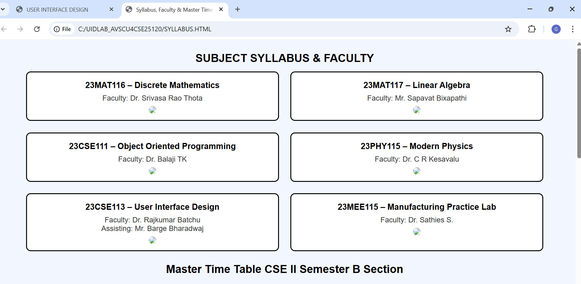
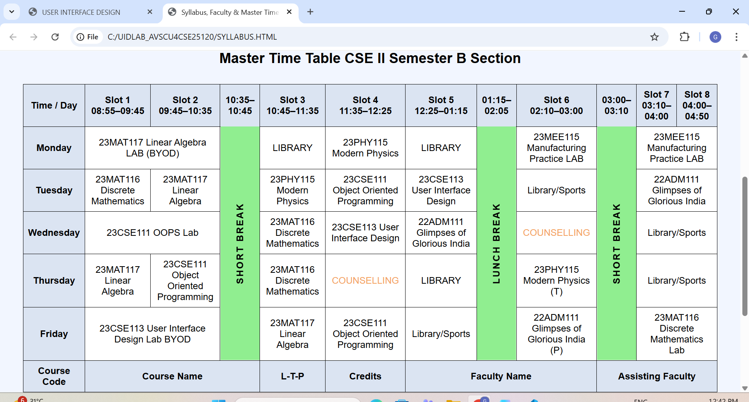

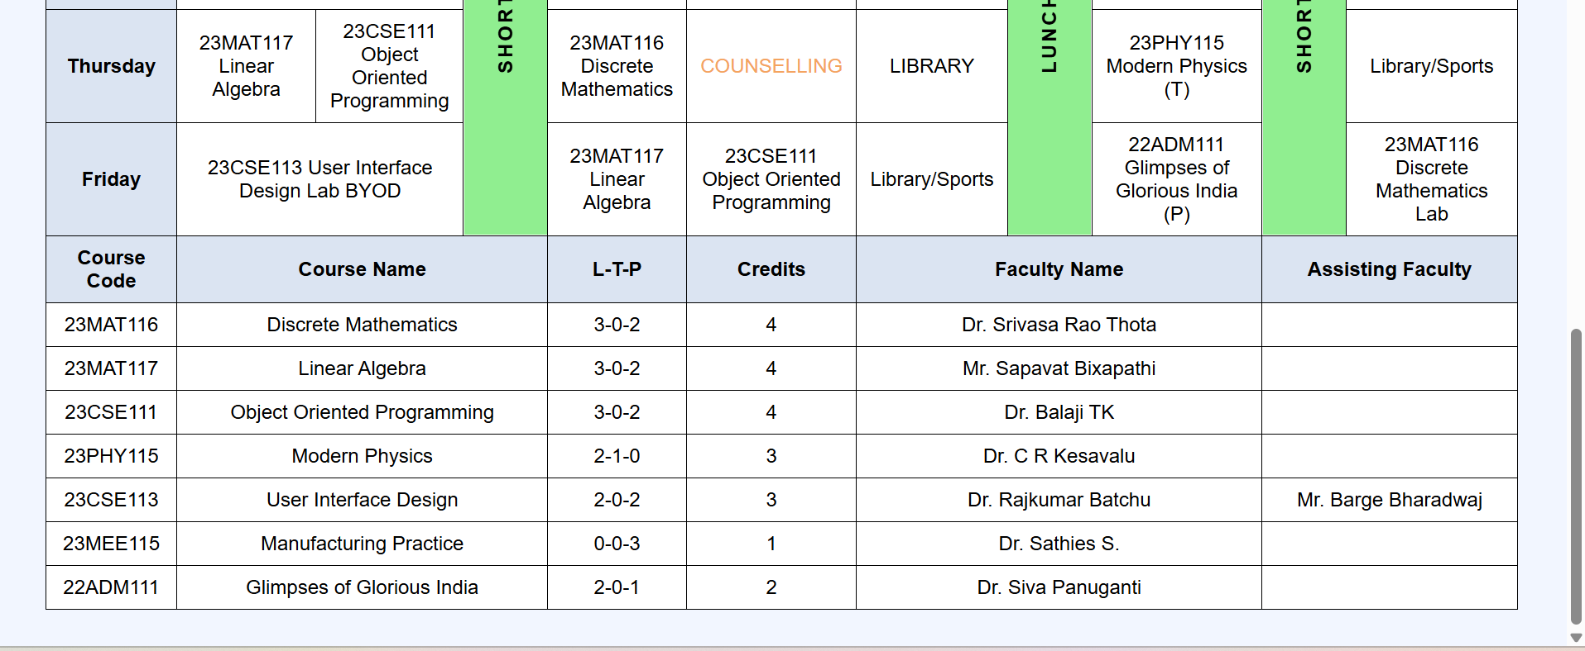

Explanation of the tags:
<div>: is used as a container to group content like gallery and cards.
<img>: tag is used to display syllabus images using the src attribute.
CSS classes like .gallery, .card, .title, .faculty, and .break are introduced for styling.
display : grid is used to create a two-column gallery layout.
margin : auto centers the content on the page. border-radius is used to give rounded corners to cards and images. border-collapse : collapse makes the table borders neat.
font-family changes the text style of the whole page.
Combined selector td, th applies common styles. HTML comments <!-- -->are used to organize the code into sections.

Week-4
1 . Aim : A college wants to collect student details through an online admission form design a registration form using only html tags(no css) with propern labels table alignment,background color and borders Procedure :
<!DOCTYPE html>
<html>
<head>
<title>College Online Admission Form</title>
<style>
/* Styles for the pop-up (Modal) */
#successModal {
display: none; /* Hidden by default */
position: fixed;
z-index: 1;
left: 0;
top: 0;
width: 100%;
height: 100%;
background-color: rgba(0,0,0,0.5); /* Black background with opacity */
}

.modal-content {
background-color: #ffffff;
margin: 15% auto;
padding: 20px;
border: 1px solid #888;
width: 30%;
text-align: center;
border-radius: 10px;
box-shadow: 0 4px 8px rgba(0,0,0,0.2);
}

.close-btn {
background-color: #4CAF50;
color: white;
padding: 10px 20px;
border: none;
border-radius: 5px;
cursor: pointer;
margin-top: 15px;
}
</style>

<script>
function showPopup(event) {
// Stop the page from refreshing
event.preventDefault();

// Show the hidden modal div
document.getElementById("successModal").style.display = "block";
return false;
}

function closePopup() {
// Hide the modal and reset the form
document.getElementById("successModal").style.display = "none";
document.getElementById("admissionForm").reset();
}
</script>
</head>

<body bgcolor="#e6f2ff">

<h2 align="center">COLLEGE ONLINE ADMISSION FORM</h2>

<form id="admissionForm" onsubmit="return showPopup(event)">
<table border="2" align="center" cellpadding="8" cellspacing="0" width="70%" bgcolor="#ffffff">

<tr>
<td colspan="2" align="center" bgcolor="#d1e0f0"><b>Student Personal Details</b></td>
</tr>

<tr>
<td><label for="fname">First Name:</label></td>
<td><input type="text" id="fname" name="fname" required></td>
</tr>

<tr>
<td><label for="lname">Last Name:</label></td>
<td><input type="text" id="lname" name="lname" required></td>
</tr>

<tr>
<td><label for="dob">Date of Birth:</label></td>
<td><input type="date" id="dob" name="dob" required></td>
</tr>

<tr>
<td><label>Gender:</label></td>
<td>
<input type="radio" name="gender" value="male"> Male
<input type="radio" name="gender" value="female"> Female
<input type="radio" name="gender" value="other"> Other
</td>
</tr>

<tr>
<td><label for="email">Email ID:</label></td>
<td><input type="email" id="email" name="email" required></td>
</tr>

<tr>
<td><label for="phone">Mobile Number:</label></td>
<td><input type="tel" id="phone" name="phone" required></td>
</tr>

<tr>
<td><label for="address">Address:</label></td>
<td><textarea id="address" name="address" rows="4" cols="30"></textarea></td>
</tr>

<tr>
<td><label for="course">Course Applying For:</label></td>
<td>
<select id="course" name="course">
<option>B.Tech</option>
<option>B.Sc</option>
<option>B.Com</option>
<option>BCA</option>
<option>MCA</option>
</select>
</td>
</tr>

<tr>
<td><label for="marks">12th Marks (%):</label></td>
<td><input type="number" id="marks" name="marks"></td>
</tr>

<tr>
<td><label>Hobbies:</label></td>
<td>
<input type="checkbox" name="hobby"> Reading
<input type="checkbox" name="hobby"> Sports
<input type="checkbox" name="hobby"> Music
</td>
</tr>

<tr>
<td><label for="photo">Upload Photo:</label></td>
<td><input type="file" id="photo" name="photo"></td>
</tr>

<tr>
<td colspan="2" align="center">
<input type="submit" value="Submit" style="cursor:pointer">
<input type="reset" value="Reset" style="cursor:pointer">
</td>
</tr>

</table>
</form>

<div id="successModal">
<div class="modal-content">
<h2 style="color: #4CAF50;">Success!</h2>
<p>Your admission form has been submitted successfully.</p>
<button class="close-btn" onclick="closePopup()">OK</button>
</div>
</div>

</body>
</html>
Output:
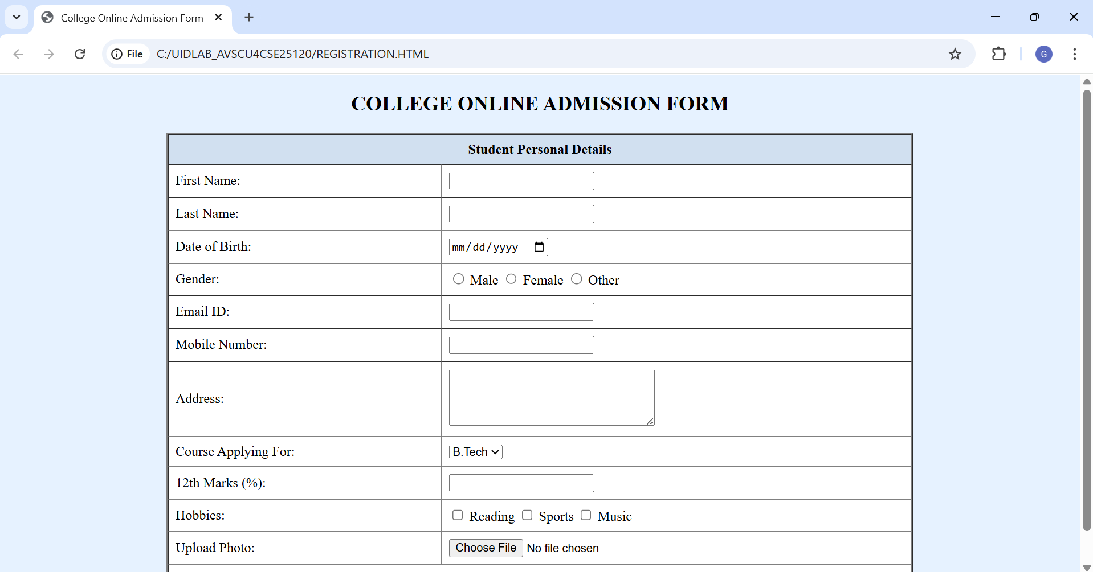

Explanation of the tags:

<form>– Collects user input
colspan – Merges two columns into one
<label for>. – Labels input fields. – Takes user input (text, date, radio, email, tel, number, file, reset).
<textarea>– Multi-line text input. & –
<select>&<option> Dropdown list. checkbox – Multiple selections. – Shows alert message. Attributes: id, name, align, bgcolor, rows, cols, border, width – control layout and identification.

2 . AIM: A Company wants to design a webpage that display two different forms side by side using iframes in which one should display a login form and other should display register form
Program :
<!DOCTYPE html>
<html>
<head>
<title>Login Form</title>
</head>
<body bgcolor="#e6f2ff">
<h2 align="center">Login Form</h2>
<form align="center">
<table border="1" cellpadding="8" align="center">
<tr>
<td>Username:</td>
<td><input type="text" name="uname"></td>
</tr>
<tr>
<td>Password:</td>
<td><input type="password" name="pass"></td>
</tr>
<tr>
<td colspan="2" align="center">
<input type="submit" value="Login">
</td>
</tr>
</table>
</form>
</body>
</html>
<______Register form_______>
<!DOCTYPE html>
<html>
<head>
<title>Register Form</title>
</head>
<body bgcolor="#fff0e6">
<h2 align="center">Register Form</h2>
<form align="center">
<table border="1" cellpadding="8" align="center">
<tr>
<td>Full Name:</td>
<td><input type="text" name="fname"></td>
</tr>
<tr>
<td>Email:</td>
</head>
<body>
<td><input type="email" name="email"></td>
</tr>
<tr>
<td>Password:</td>
<td><input type="password" name="pass"></td>
</tr>
<tr>
<td>Confirm Password:</td>
<td><input type="password" name="cpass"></td>
</tr>
<tr>
<td>Confirm Password:</td>
<td><input type="password" name="cpass"></td>
</tr>
<tr>
<td colspan="2" align="center">
<input type="submit" value="Register">
</td>
</tr>
</table>
</form>
</body>
</html>
<______Main page_______>
<!DOCTYPE html>
<html>
<head>
<title>Login and Register</title>
<h1 align="center">User Authentication Page</h1>
<table width="100%">
<tr>
<td width="50%" align="center">
<iframe src="login.html" width="90%" height="400"></iframe>
</td>
<td width="50%" align="center">
<iframe src="register.html" width="90%" height="400"></iframe>
</td>
</tr>
</table>
</body>
</html>

Top of Form

OUTPUT:
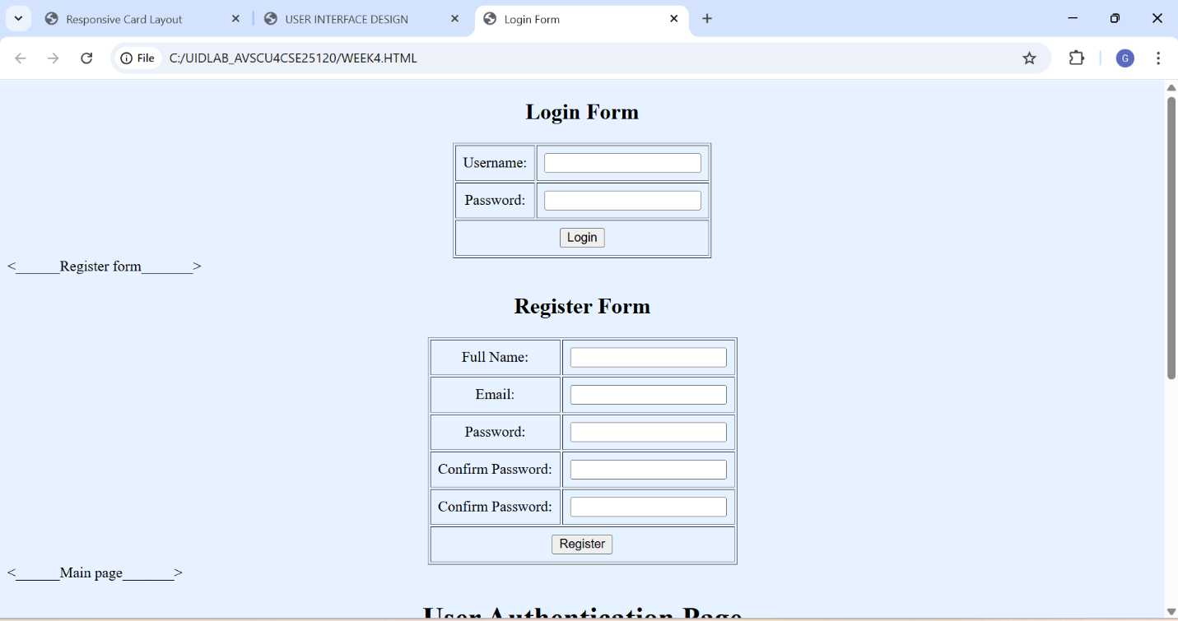

Explanation of the tags: (Inline Frame): Displays another HTML page inside the current page. Two separate pages are created: Login Form and Register Form. A main page uses two iframes to show both forms side by side. src attribute: Specifies which page to load inside the iframe. width & height: Set the iframe size. A table with two columns is used to align the iframes in one row. Each iframe loads a different form page (login / register).

Week-5
1 . Aim : To create a responsive card layout using HTML and CSS with three cards, each containing an image, title, and button.
Procedure:
<!DOCTYPE html>
<html>
<head>
<title>Card Layout with Images</title>

<style>
body{
font-family: Arial, sans-serif;
background-color: #f2f2f2;
}

.container{
display: flex;
justify-content: center;
gap: 20px;
margin-top: 50px;
}

.card{
background-color: white;
width: 260px;
border-radius: 10px;
box-shadow: 0 4px 8px rgba(0,0,0,0.2);
overflow: hidden;
text-align: center;
}

.card img{
width: 100%;
height: 180px;
object-fit: cover;
}

.card h3{
margin: 15px 0 10px 0;
}

.card p{
font-size: 14px;
padding: 0 15px;
color: gray;
}

.card button{
margin: 15px 0 20px 0;
padding: 8px 15px;
border: none;
background-color: #007bff;
color: white;
border-radius: 5px;
cursor: pointer;
}

.card button:hover{
background-color: #0056b3;
}
</style>
</head>

<body>

<div class="container">

<div class="card">
<img src="https://picsum.photos/300/200?1" alt="Image 1">
<h3>Card 1</h3>
<p>This is the first card description.</p>
<button>Read More</button>
</div>

<div class="card">
<img src="https://picsum.photos/300/200?2" alt="Image 2">
<h3>Card 2</h3>
<p>This is the second card description.</p>
<button>Read More</button>
</div>

<div class="card">
<img src="https://picsum.photos/300/200?3" alt="Image 3">
<h3>Card 3</h3>
<p>This is the third card description.</p>
<button>Read More</button>
</div>

</div>

</body>
</html>

OUTPUT:
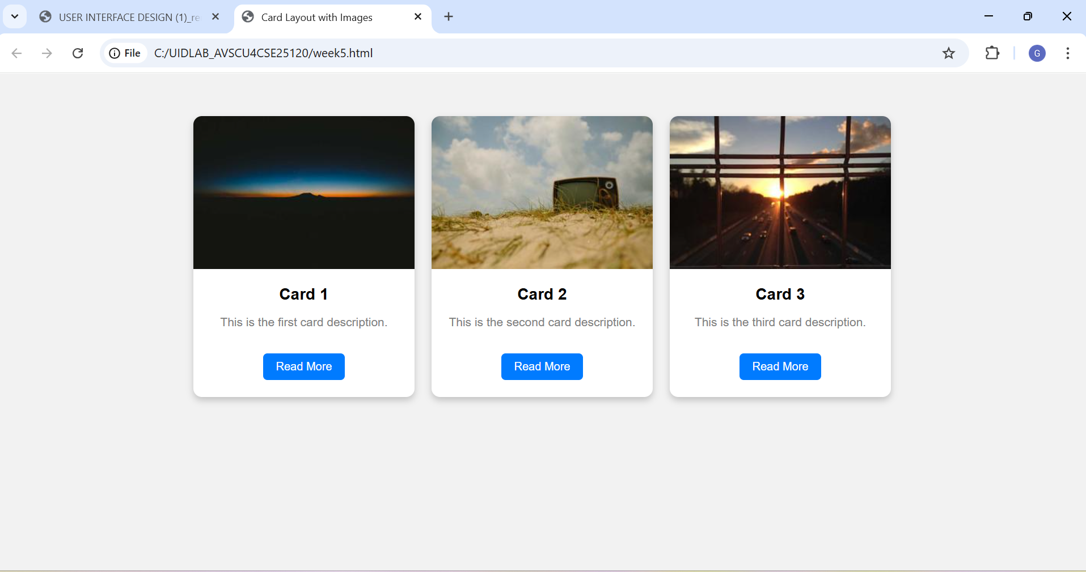
Explanation of the tags:
- flex → Align items in row
- box-shadow → Adds shadow
- border-radius → Rounded corners
- object-fit: cover → Adjust image without distortion
- :hover → Changes style when mouse is over element
- overflow: hidden → Hides extra content outside border
2.Aim: To design a mini website using iframe navigation links (Home, About, Contact), where clicking on each link displays the respective content within the same page using internal or external CSS.
Procedure:
<!DOCTYPE html>
<html>
<body>
<h2>This page contains information about the page.</h2>
</body>
</html>
about.html
<!DOCTYPE html>
<html>
<body>
<h2>if having any issues regarding this</h2>
<p>gayathri@2008gmail.com</p>
<p>phone:1234567890</p>
</body>
</html>
contact.html
<!DOCTYPE html>
<html>
<body>
<h2>This is my Website.Here is the content of this page.</h2>
</body>
</html>
home.html
<!DOCTYPE html>
<html>
<head>
<title> Website with iFrame</title>
<link rel="stylesheet" href="style.css">
</head>
<body>

<header>
<h1>My Mini Website</h1>
</header>

<nav>
<a href="home.html" target="contentFrame">Home</a>
<a href="about.html" target="contentFrame">About</a>
<a href="contact.html" target="contentFrame">Contact</a>
</nav>

<section>
<iframe name="contentFrame" src="home.html"></iframe>
</section>

</body>
</html>
Output:
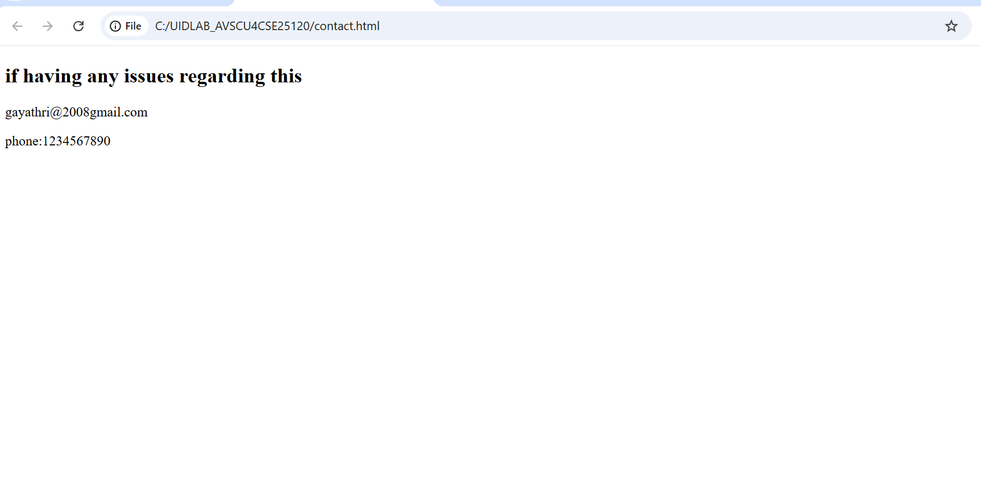

Explanation of tags :
<header>
Used for top section of webpage.
<nav>
Used for navigation links.
<section>
Used to divide content into sections.
<a>
Anchor tag.
Used to create hyperlinks.
Important attributes:
href → Link address
target → Where to open the link
<iframe>
Used to display another webpage inside current webpage.
Important attributes:
src → Page to display
name → Used with targe

EXPLANATION OF THE TAGS :
<header>
- Used for top section of webpage.
<nav>
- Used for navigation links.
<section>
- Used to divide content into sections.
<a>
- Anchor tag.
- Used to create hyperlinks.
- Important attributes: href → Link address target → Where to open the link
<iframe>
- Used to display another webpage inside current webpage.
- Important attributes: src → Page to display name → Used with targe

3.Aim: To design an Amrita login page using HTML and CSS that displays different campuses, where clicking each campus shows its details on the same page
Procedure:
<!DOCTYPE html>
<html>
<head>
<title>Amrita Login Page</title>
<style>
body {
margin: 0;
font-family: Arial, sans-serif;
background: linear-gradient(to right,light orange, pale pink);
background: url(https://wallpapers.com/images/hd/cool-light-blue-l6csxyf32ij7t1or.jpg) no-repeat center center/cover
}
/* Header */
.header {
background-color:lightcoral;
color: white;
text-align: center;
padding: 15px;
font-size: 28px;
font-weight: bold; }
/* Navigation */
.nav {
background-color:darkcyan;
text-align: center;
padding: 10px; }
.nav button {
background: transparent;
border: none;
color:lightgoldenrodyellow;
font-size: 16px;
margin: 0 15px;
cursor: pointer; }
.nav button:hover {
text-decoration: underline; }
/* Main Layout */
.container {
display: flex;
justify-content: center;
align-items: flex-start;
margin: 40px;
gap: 40px; }
/* Login Box */
.login-box {
background: linear-gradient(to bottom,darkviolet,lightcoral);
padding: 25px;
width: 300px;
border-radius: 10px;
color:darkcyan; }
.login-box h2 {
text-align: center; }
.login-box input {
width: 100%;
padding: 8px;
margin: 10px 0;
border: none;
border-radius: 4px;}
.login-box button {
width: 100%;
padding: 8px;
background-color:darkseagreen;
color:light turquoise;
border: none;
border-radius: 4px;
cursor: pointer;}
/* Campus Details */
.campus-details {
background:palegoldenrod;
width: 500px;
padding: 20px;
border-radius: 10px; }
.campus-details img {
width: 100%;
height: 200px;
object-fit: cover;
margin-top: 10px; }
</style>
</head>
<body>
<div class="header">
AMRITA VISHWA VIDHYAPEETAM
</div>
<div class="nav">
<button onclick="showCampus('coimbatore')">Coimbatore</button>
<button onclick="showCampus('amritapuri')">Amritapuri</button>
<button onclick="showCampus('bangalore')">Bangalore</button>
<button onclick="showCampus('chennai')">Chennai</button>
<button onclick="showCampus('Amaravathi')">Amaravathi</button>
</div>
<div class="container">
<!-- Login Section -->
<div class="login-box">
<h2>Login</h2>
<input type="text" placeholder="Email">
<input type="password" placeholder="Password">
<button>Login</button>
</div>
<!-- Campus Info Section -->
<div class="campus-details" id="campusInfo">
<h2>About the Campus</h2>
<p>Select a campus from above to view details.</p>
</div>
<script>
function showCampus(campus) {
let info = document.getElementById("campusInfo");
if (campus === "coimbatore") {
info.innerHTML = `
<h2>Coimbatore Campus</h2>
<p>Located in Tamil Nadu. Known for Engineering and Technology programs with modern infrastructure.</p>
<img src="https://tse3.mm.bing.net/th/id/OIP.elkN6U_aVSlLuBTcPX2q_QHaEK?pid=Api&P=0&h=180"
alt="Coimbatore Campus"> `; }
else if (campus === "amritapuri") {
info.innerHTML = `
<h2>Amritapuri Campus</h2>
<p>Located in Kerala. Famous for Arts, Science and research activities in a peaceful environment.</p>
<img src="https://tse4.mm.bing.net/th/id/OIP.jPuLxk4ALi6yUzvKevF7fgHaEM?pid=Api&P=0&h=180" alt="Amritapuri
Campus"> `;}
else if (campus === "bangalore") {
info.innerHTML = `
<h2>Bangalore Campus</h2>
<p>Located in Karnataka. Offers Engineering and Management programs with industry exposure.</p>
<img src="https://tse4.mm.bing.net/th/id/OIP.AxDXEuEdONmn1Poym0qaiQHaDt?pid=Api&P=0&h=180"
alt="Bangalore Campus">`; }
else if (campus === "chennai") {
info.innerHTML = `
<h2>Chennai Campus</h2>
<p>Located in Tamil Nadu. Special focus on engineering disciplines and innovation.</p>
<img src="https://tse2.mm.bing.net/th/id/OIP.5Cd4ekgT1P_EX7zhzH_D1AHaDp?pid=Api&P=0&h=180"
alt="Chennai Campus">
`;
}
else if (campus === "Amaravathi") {
info.innerHTML = `
<h2>Amaravathi Campus</h2>
<p>Located in Mangalagiri. Famous for Arts, Science and research activities in a peaceful environment.</p>
<img src="https://tse4.mm.bing.net/th/id/OIP.WIKj0_HGLKy7-vepQuwuLwHaDK?pid=Api&P=0&h=180"
alt="Amaravathi Campus">;}}
</script>
</body>
</html>

Output:
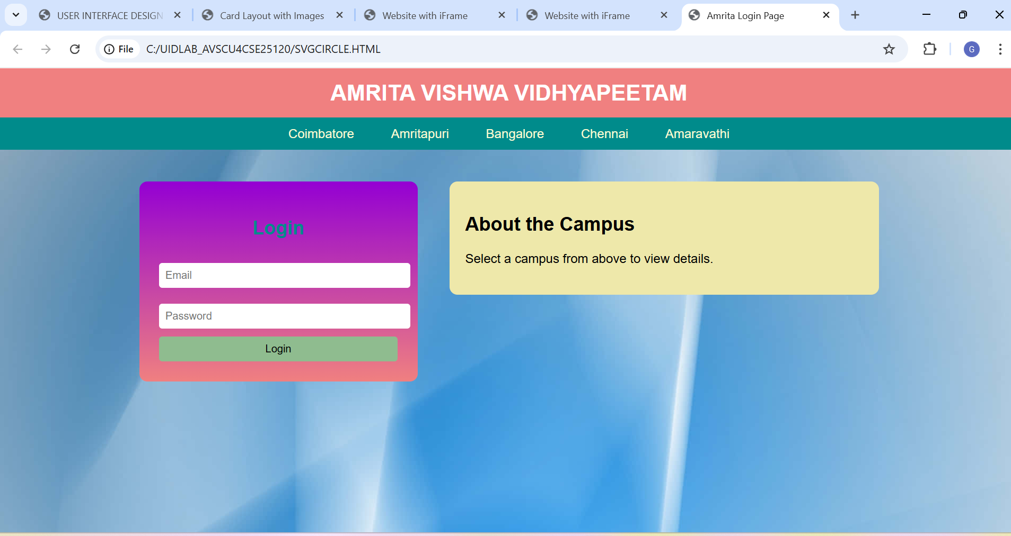

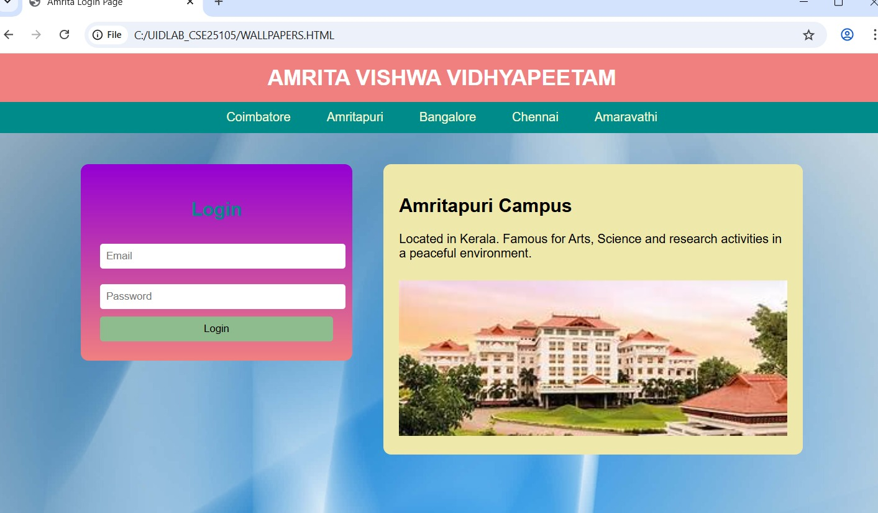

Explanation of the tags:
CSS Styling
🔹 body Sets background image.
Removes margin.
Applies font style.
🔹 .header
Top banner.
Background color: lightcoral.
Center aligned white text.
🔹 .nav
Navigation bar.
Contains buttons for campuses.
🔹 .container
Uses display: flex;
Aligns login box and campus details side by side.
🔹 .login-box
Styled login form.
Gradient background.
Rounded corners.
🔹 .campus-details
Displays campus information.
Contains heading, paragraph and image.
Navigation Buttons
Coimbatore
onclick calls JavaScript function.
Sends campus name as parameter.
Week 6
1. <!DOCTYPE html>
<html>
<head>
<title>gayathri Shopping</title>

<style>
body{
margin:0;
font-family:Arial, Helvetica, sans-serif;
background:lightyellow;
}

.header{
background:lightcoral;
color:white;
text-align:center;
padding:15px;
font-size:22px;
}

.sale{
background:lemonchiffon;
text-align:center;
padding:10px;
font-weight:bold;
}

.container{
display:flex;
padding:8px;
}

.sidebar{
width:200px;
background:mistyrose;
padding:10px;
border-radius:8px;
}

.sidebar button{
width:100%;
padding:8px;
margin:4px 0;
border:none;
background:lightpink;
cursor:pointer;
}

.products{
flex:1;
display:grid;
grid-template-columns:repeat(3,1fr); /* 3 items per row */
gap:10px; /* reduced gap */
padding:5px;
}

.card{
background:lightgoldenrodyellow;
padding:10px;
text-align:center;
border-radius:6px;
}

.card img{
width:100%;
height:120px; /* smaller height */
object-fit:cover;
}

.price{
color:indianred;
font-weight:bold;
}

.card button{
background:salmon;
color:white;
border:none;
padding:6px 12px;
margin-top:6px;
cursor:pointer;
}

.footer{
background:salmon;
color:white;
text-align:center;
padding:10px;
margin-top:8px;
}
</style>

<script>
function showCategory(category){
let products=document.querySelectorAll(".card");
products.forEach(function(product){
if(category=="all"){
product.style.display="block";
}
else if(product.classList.contains(category)){
product.style.display="block";
}
else{
product.style.display="none";
}
});
}
</script>
</head>

<body>

<div class="header">
Hasinishekhar SPA Shopping
</div>

<div class="sale">
Ugadi Special Sale – Up to 70% Off
</div>

<div class="container">

<div class="sidebar">
<h3>Categories</h3>
<button onclick="showCategory('viewitems')">View Items</button>
<button onclick="showCategory('furniture')">Furniture</button>
<button onclick="showCategory('clothing')">Clothing</button>
<button onclick="showCategory('appliances')">Home Appliances</button>
<button onclick="showCategory('stationary')">Stationary</button>
<button onclick="showCategory('groceries')">Groceries</button>
<button onclick="showCategory('beauty')">Beauty Products</button>
<button onclick="showCategory('all')">Show All</button>
</div>

<div class="products">

<!-- View Items (first category, highlights) -->
<div class="card viewitems">
<img src="sofa2.html">
<h3>Furniture</h3>
<p class="price">55000/-</p>
<button>Add to Cart</button>
</div>

<div class="card viewitems">
<img src="t shirt .html">
<h3>Clothing</h3>
<p class="price">700/-</p>
<button>Add to Cart</button>
</div>

<div class="card viewitems">
<img src="washing machine.html">
<h3>Appliances</h3>
<p class="price">12000/-</p>
<button>Add to Cart</button>
</div>

<div class="card viewitems">
<img src="stationary.html">
<h3>Stationary</h3>
<p class="price">120/-</p>
<button>Add to Cart</button>
</div>

<div class="card viewitems">
<img src="vegitables.html">
<h3>Groceries</h3>
<p class="price">180/-</p>
<button>Add to Cart</button>
</div>

<div class="card viewitems">
<img src="https://images.unsplash.com/photo-1522335789203-aabd1fc54bc9">
<h3>Beauty</h3>
<p class="price">800/-</p>
<button>Add to Cart</button>
</div>

<!-- Furniture -->
<div class="card furniture">
<img src="sofa2.html">
<h3>Sofa Set</h3>
<p class="price">55000/-</p>
<button>Add to Cart</button>
</div>

<div class="card furniture">
<img src="bed.html">
<h3>Wooden Bed</h3>
<p class="price">30000/-</p>
<button>Add to Cart</button>
</div>

<div class="card furniture">
<img src="table.html">
<h3>Dining Table</h3>
<p class="price">15000/-</p>
<button>Add to Cart</button>
</div>

<div class="card furniture">
<img src="chair.html">
<h3>Wooden Chair</h3>
<p class="price">5000/-</p>
<button>Add to Cart</button>
</div>

<!-- Clothing -->
<div class="card clothing">
<img src="t shirt .html">
<h3>T-Shirt</h3>
<p class="price">700/-</p>
<button>Add to Cart</button>
</div>

<div class="card clothing">
<img src="jackets2.html">
<h3>Jacket</h3>
<p class="price">1200/-</p>
<button>Add to Cart</button>
</div>

<div class="card clothing">
<img src="jeans.html">
<h3>Jeans</h3>
<p class="price">1500/-</p>
<button>Add to Cart</button>
</div>

<div class="card clothing">
<img src="dress.html">
<h3>Dress</h3>
<p class="price">2000/-</p>
<button>Add to Cart</button>
</div>

<!-- Appliances -->
<div class="card appliances">
<img src="washing machine.html">
<h3>Washing Machine</h3>
<p class="price">12000/-</p>
<button>Add to Cart</button>
</div>

<div class="card appliances">
<img src="refrigerator.html">
<h3>Refrigerator</h3>
<p class="price">15000/-</p>
<button>Add to Cart</button>
</div>

<div class="card appliances">
<img src="microwave2.html">
<h3>Microwave</h3>
<p class="price">8000/-</p>
<button>Add to Cart</button>
</div>

<div class="card appliances">
<img src="ac.html">
<h3>Air Conditioner</h3>
<p class="price">35000/-</p>
<button>Add to Cart</button>
</div>

<!-- Stationary -->
<div class="card stationary">
<img src="book.html">
<h3>Notebook</h3>
<p class="price">120/-</p>
<button>Add to Cart</button>
</div>

<div class="card stationary">
<img src="pens.html">
<h3>Pens</h3>
<p class="price">80/-</p>
<button>Add to Cart</button>
</div>

<div class="card stationary">
<img src="kit.html">
<h3>School Kit</h3>
<p class="price">250/-</p>
<button>Add to Cart</button>
</div>

<div class="card stationary">
<img src="files.html">
<h3>Office Supplies</h3>
<p class="price">300/-</p>
<button>Add to Cart</button>
</div>

<!-- Groceries -->
<div class="card groceries">
<img src="vegitables.html">
<h3>Vegetables</h3>
<p class="price">200/-</p>
<button>Add to Cart</button>
</div>

<div class="card groceries">
<img src="fruits.html">
<h3>Fruits</h3>
<p class="price">180/-</p>
<button>Add to Cart</button>
</div>

<div class="card groceries">
<img src="food.html">
<h3>Food Pack</h3>
<p class="price">350/-</p>
<button>Add to Cart</button>
</div>

<div class="card groceries">
<img src="organic.html">
<h3>Organic Groceries</h3>
<p class="price">400/-</p>
<button>Add to Cart</button>
</div>

<!-- Beauty -->
<div class="card beauty">
<img src="makeup.html">
<h3>Makeup Kit</h3>
<p class="price">1600/-</p>
<button>Add to Cart</button>
</div>

<div class="card beauty">
<img src="lipstick.html">
<h3>Lipsticks</h3>
<p class="price">800/-</p>
<button>Add to Cart</button>
</div>
Output :
